**Prerequisite to create Target Groups:**

1. EC2 Instance

Step to create target group:

1. Goto EC2 dashboard.
2. Then from left side click on Target Groups.

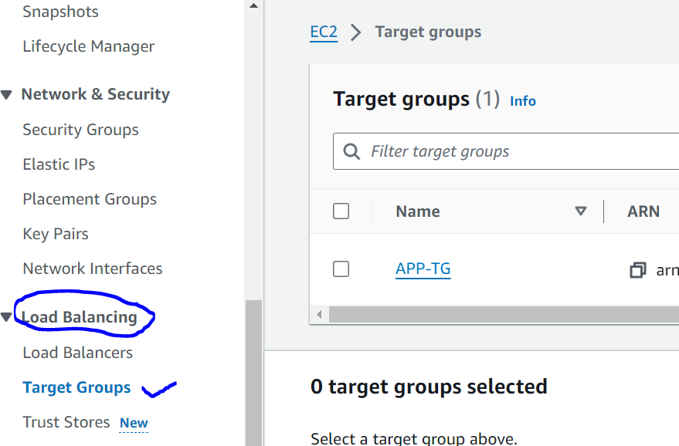

1. Then click on **Create Target Group.**

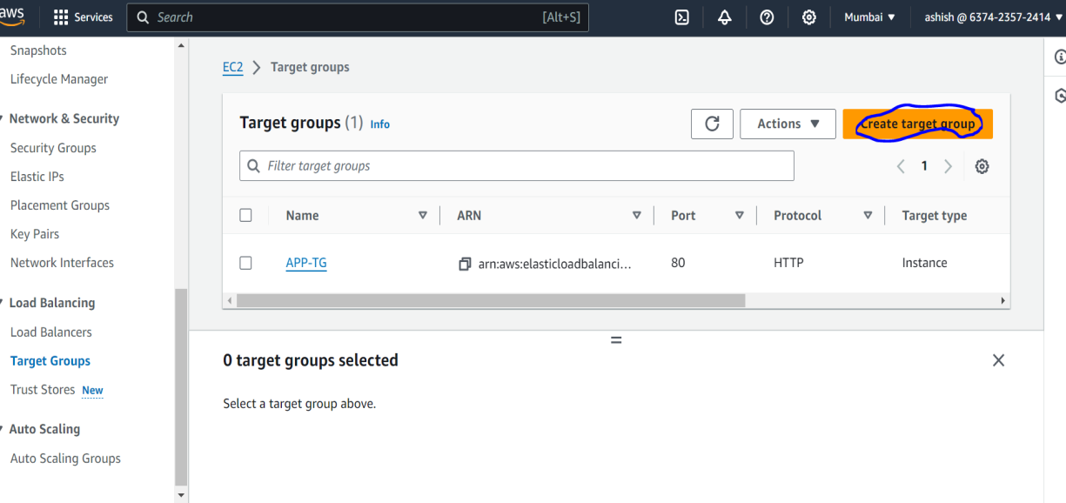

1. In **Basic configuration,** select **Instance.**

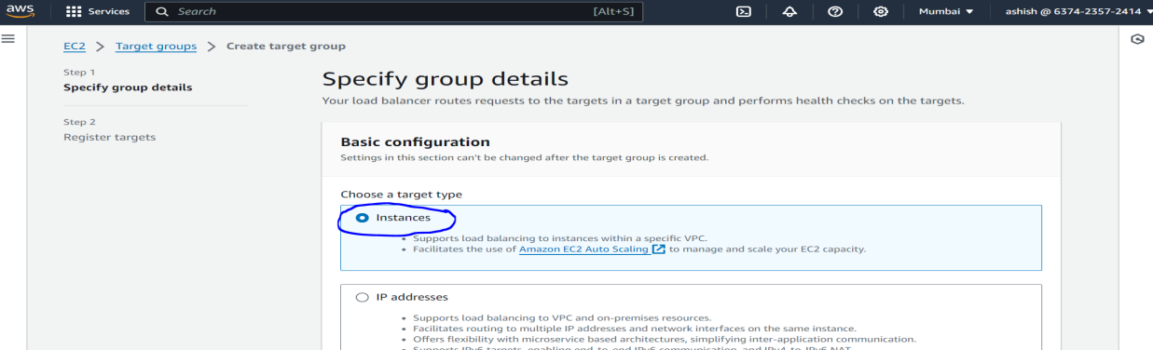

1. Then give Target group name.
2. Then In Protocol : Port select HTTP and Port 80
3. Then In **IP address type, select IPv4**

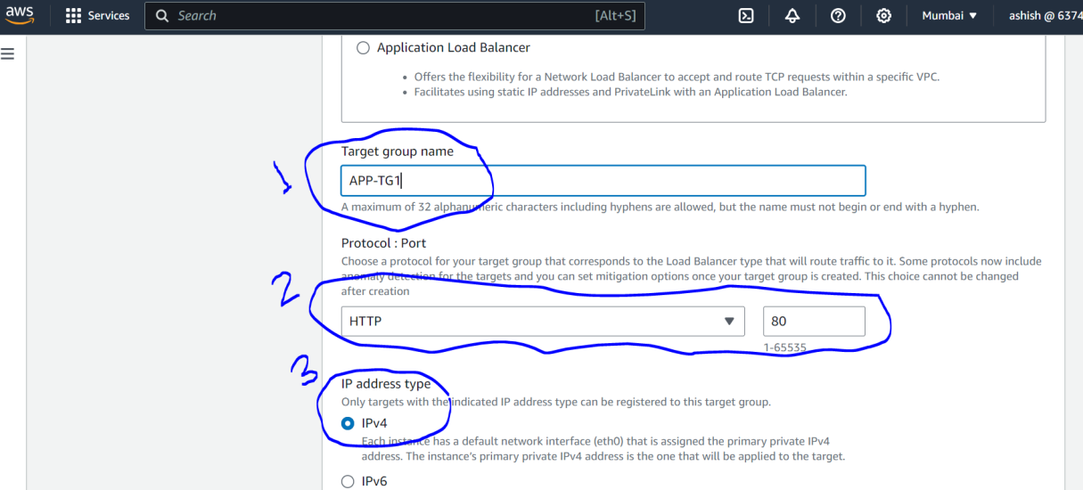

1. Then select **VPC.**
2. In Protocol version, select HTTP1

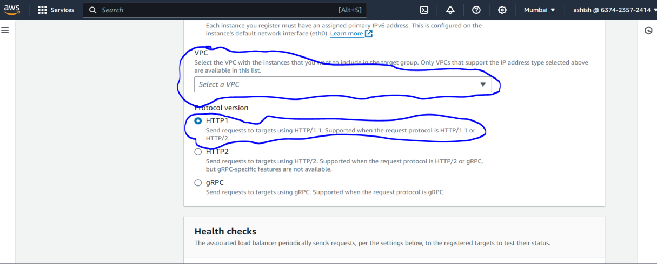

1. In **Health checks select HTTP and Health check path** enter you your application name /appname.

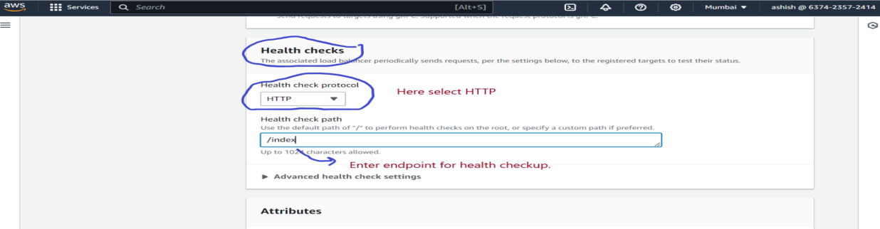

1. Then click next.
2. On next Page, In **Register targets**, goto **Available instances** and select ec2 instance for which you want to create target group.
3. Then Goto **Include as pending below** and enter port number on which ec2 instance application is running.
4. Then click on **Include as pending below.**

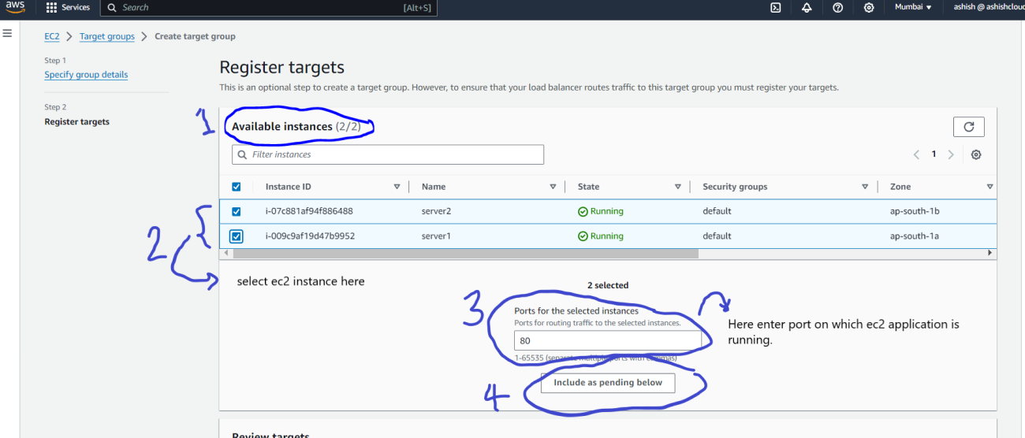

1. Once you clicked on **Include as pending below** then go toReview targets, you can see all instances which you have selected.

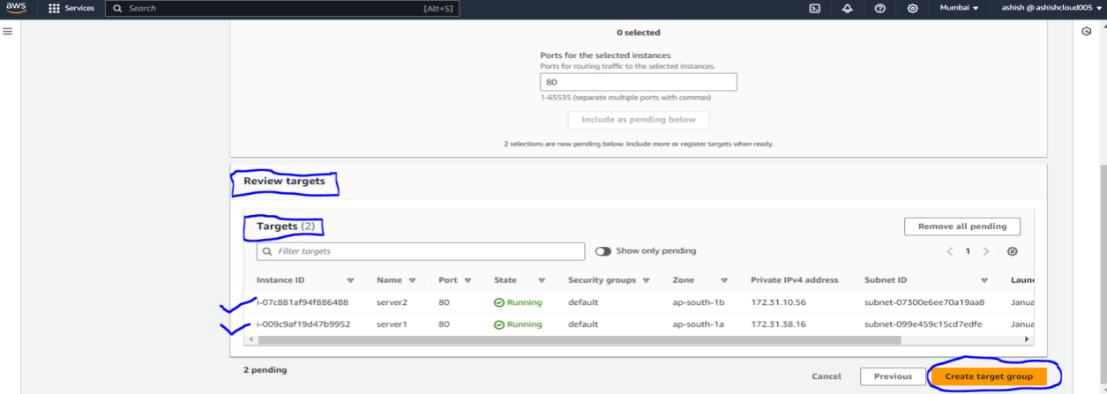

**Note:** If you want to create empty target group then don’t select step 12, 13 and 14.

1. Then click on **Create target group**.